To: Head of Office of Policy Analysis

From: Craig Moxley

Date: 03/29/2014

RE: Proceed with the supported work program for TANF recipients but not for ex-addicts

The Department of Labor (DoL) should implement the supported work program for current TANF recipients, as it is both cost-effective and efficient at achieving DoL goals of preparing participants for the work force. TANF recipients show significant increases in post-program employment, and their benefits will only continue to grow with time. The DoL should explore other options for ex-addicts. The program for ex-addicts comes at a net cost to society and generates serious distributional concerns. It also does not accomplish DoL goals as it has only mild and short-term effects on labor participation and crime rates.

Proceed with Program for TANF Recipients

**The supported work program for TANF recipients produces net benefits**

For current TANF recipients, strong in-program output[1] and post-program output[2] drive the cost-effectiveness of the supported work program [See Table 1]. The Rest of Society (ROS) and TANF recipients share the benefits, and there are no serious distributional concerns. The ROS benefits $2578 per participant primarily due to lower transfers to TANF recipients. These transfers from TANF recipients do not actually count to the benefits of society as a whole. TANF recipients benefit primarily from in-program and post-program wages. These wages are large enough that TANF recipients each still benefit $232 after forfeiting welfare transfers of $11308. Additionally, the data included in Table 1 only account for the program year and two subsequent years. But, the upward trend in post-program output and continued administrative savings indicate that the program will continue to generate net benefits for recipients and ROS after two years.

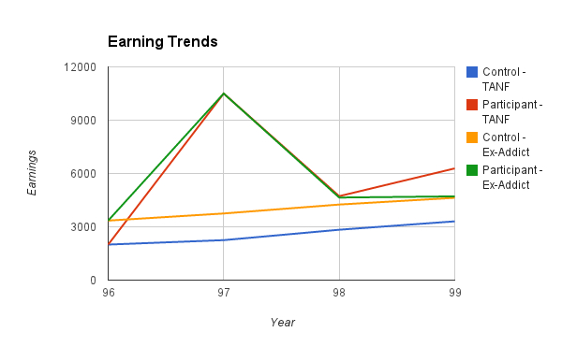**The program prepares workers for the labor force and improves their labor status**

TANF recipients appear to satisfy the DoL’s primary goal for the supported work program: data on their post-program income indicates that TANF recipients’ employment status improves after the program ends. The red line in Figure 1 illustrates how two years after completing the program (in year 1999) TANF recipients in the program have incomes that are twice as high as TANF recipients who did not join the program. Income growth among TANF recipients is important given the replacement of old welfare programs with the time-limited TANF Program.

Figure

**Sensitivity concerns are not strong enough to impede program implementation**

Despite net benefits and the strong possibility of continued benefits, it is possible – but unlikely – that the program could come at a net cost to society and/or to TANF recipients. Two scenarios illustrate the sensitivity of the conclusions: first, if in-program output is less than $7,940, the program will come at net cost to society. Second, if TANF recipients make 5.5% less in post-program output in the two years following the program, they will no longer receive net benefits from the program.

Do Not Continue Program for Ex-Addicts

**The supported work program for ex-addicts recipients produces net costs**

The program for ex-addicts generates net costs of $1689 per participant in large part due to insignificant post-program output and short-term arrest savings. The distribution of costs also raises significant distributional issues. Each ex-addict benefits $6,444, while the rest of society faces a net cost of $8,119 per participant. The lower income nature of ex-addicts does not justify such a significant unequal distribution. For the program to be cost effective and not skewed distributionally, the in-program output would have to double, which does not seem possible.

**The program is also not successful at integrating ex-addicts back into the workforce**

The primary goal of the supported work program for ex-addicts is to prepare participants for the regular labor force and to improve their employment status. Figure 1 shows that two years after the program is completed, ex-addicts who participated in the program make nearly the same amount as ex-addicts who did not participate in the program.

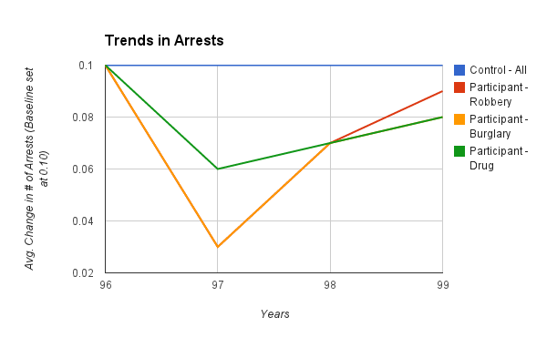**The temporary decrease in arrests is not significant enough to justify the program**

While the program produces an effect on arrests, the effect seems to decrease with time. Figure 2 shows how burglary, robbery, and drug crimes all fall during the year of the program (97), but then climb again in subsequent years. The temporary nature of this benefit provides further evidence against proceeding with supported work programs for ex-addicts.

Figure 2

**Appendix**

Table 1. CBA for Current TANF Recipients

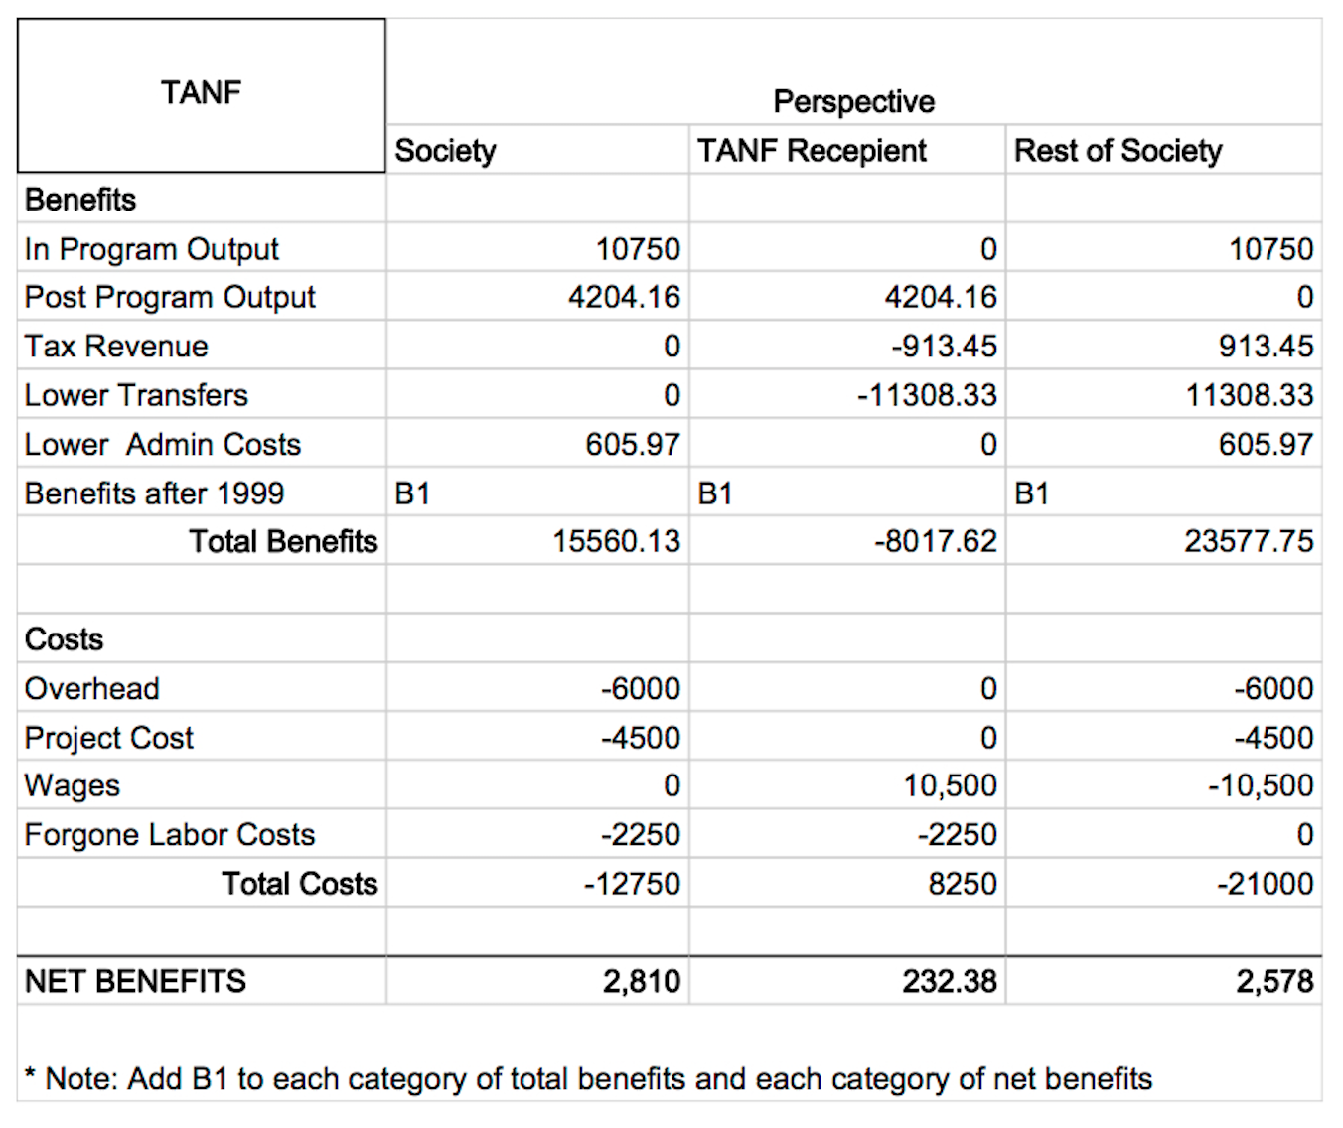

Table 2. CBA for Ex-Addicts

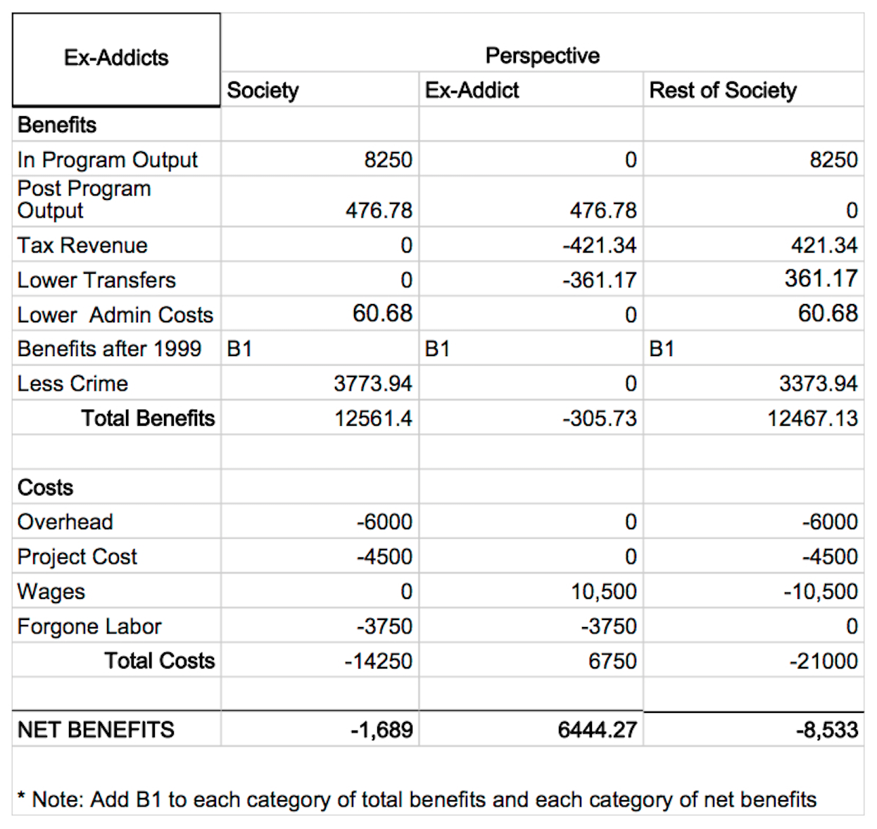

Table 3. Arrest Savings Per Participant

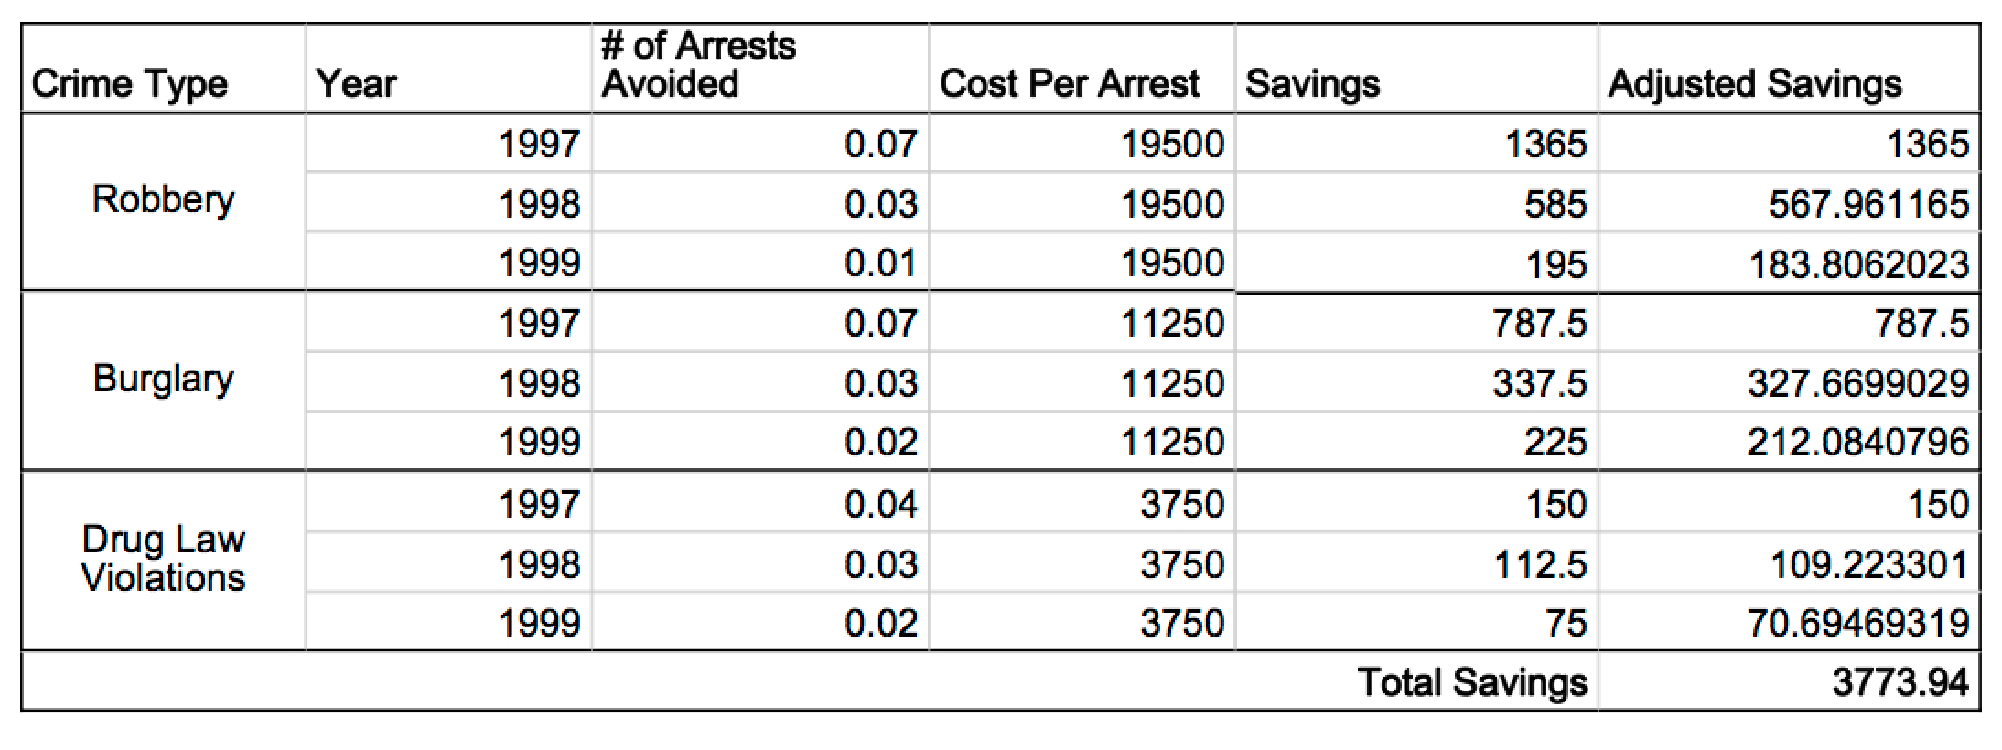

1. Measured by the prices that alternative suppliers would charge for the goods and services produced
2. Estimated by the wages earned by participants